Collaborative Sciences Center for Road Safety

PROCEEDINGS from “Transportation Funding and Finance 101: Why Funding is Policy”

Nicolas D. Norboge

February 6, 2018

In Transportation Funding and Finance 101: Why Funding is Policy, Nicolas Norboge provides an overview of transportation funding and finance by mode, as well as examples of how these funding and finance mechanisms and policies influence our decision-making. Norboge is a Research Scientist at Texas A&M University in its Infrastructure Investment Analysis Program, and a volunteer on the Revenue and Finance Committee of the Transportation Research Board.
Norboge’s work focuses on how we pay for our transportation system, and he notes that it is critical to first define the difference between funding and finance. Funding is new money that comes into an agency or government to pay for transportation assets. Funding is similar to a personal income. The biggest source of transportation funding in the United States is the gas tax, which is based on consumption. Finance, on the other hand, is made up of mechanisms that help leverage funding resources, such as enabling legislation that allows for greater private investment and involvement. Finance is similar to a mortgage. The United States is generally well-equipped with financial solutions and options, and these opportunities for finance continue to expand.
Table 1. Major Funding Mechanisms by Mode [6]
Roadways | Federal and state motor fuel taxes  State vehicle registration fees  Federal-, state-, and local-backed bonds (debt financing)
Public transit systems | Directly generated local revenues  Federal motor vehicle taxes and fees  State miscellaneous transportation-related revenues (not motor fuel taxes)
Airports | State, federal, and local grants and bonds  Terminal concessions  Parking fees  Passenger ticket facility charges  Landing fees
Ports | Direct shipper user fees  Port area city and county property taxes
Freight networks (rail) | Private railroad dollars
Intercity passenger rail | Federal and state government funds

In the United States, transportation infrastructure is built and paid for by transportation mode, as illustrated in the table above. Most modes receive some combination of federal, state, and local funding, as well as financing from the government and private investors. There are subtle but important differences in how each mode is funded and financed, which have implications for forecasting future demand and how to pay for future supply. Norboge acknowledges that future forecasts can have a degree of certainty plus or minus up to 40 percent due to monetary, population, and technology uncertainties. He discusses a variety of transportation modes and how they are funded and financed:
Highways and roadways are funded by fuels taxes, registration fees, license fees, and local property taxes. The fuel tax, commonly known as the gas tax, makes up the largest share of transportation revenue and funnels into the coffers of the federal Highway Trust Fund. Gas taxes are a huge source of revenue—the gas tax formed 41% of North Carolina’s Department of Transportation revenue source in SFY 2018 [1]. As driving rates change—as they did in the most recent recession—so does the revenue collected by the gas tax. Two major trends are depleting the Highway Trust Fund’s revenues: (1) inflation, which decreases the purchasing power of the federal gas tax which has not been changed since 1993; and (2) the improved fuel efficiency of vehicles, which lowers the amount of gas that people need to buy to drive the same distances.
Airports are funded by the Airport Improvement Grants Program—particularly smaller general aviation airports, passenger facility charges—$4.50 per passenger, state and local grants, parking fees, concessions, rental car operations, and advertising. Financing for airports is provided by General Revenue bonds (e.g., for a parking facility), General Obligation bonds (e.g., as part of an airport district), and other special facility bonds. However, recent shifts in how passengers travel to airports has created uncertainty in airport revenue models. Although airport parking is a huge source of airport revenue, it is declining in some cases by 20 to 30 percent due to passengers using Transportation Network Companies (TNCs) to get to the airport [2]. To combat this loss of revenue, some airports are looking to impose a “TNC tax.” Other airports, like RDU in the Raleigh-Durham area of North Carolina, are expanding parking facilities—perhaps counting on a capture base that lives too far away to use a TNC to travel to the airport. But rethinking what to do with empty parking lots or shifting nearby land uses to reduce the reliance on parking are difficult tasks for airport authorities, who face stringent regulations on land use due to safety considerations and strings that are attached to federal grants.
Passenger rail is another mode that faces uncertainty in its funding and financing. The National Railroad Passenger Corporation—commonly known as Amtrak—is funded through ticket sales and government subsidy. An Obama-era program called the High-Speed Intercity Passenger Rail Program (HSIPR) provided $8 billion for planning and other studies, but the funding is now depleted. Passenger rail is financed through federal credit assistance, state revolving loans, and private activity bonds. Amtrak does not own the majority of the rail that it uses, and leases it from the mostly privately-funded freight rail companies, causing conflict between freight and passenger rail travel.
To bring the examples home to North Carolina, Norboge presents data from NCDOT’s budget that show how transportation funding becomes transportation policy. NCDOT spends nearly half of its budget on constructing new roads, almost a third on maintenance of roads, and a mere 7.3 percent on all other modes including airports, ferries, transit, and bicycle and pedestrian infrastructure combined [1]. Public polling doesn’t always align with these expenditures, and recent trends are seeing local governments raising sales taxes for public transit (e.g., the Wake County Transit Tax). Some high-growth states have passed state-wide, bipartisan, major legislative bills to increase revenue for transportation, mostly used for highways (see map from Transportation for America below [3]).
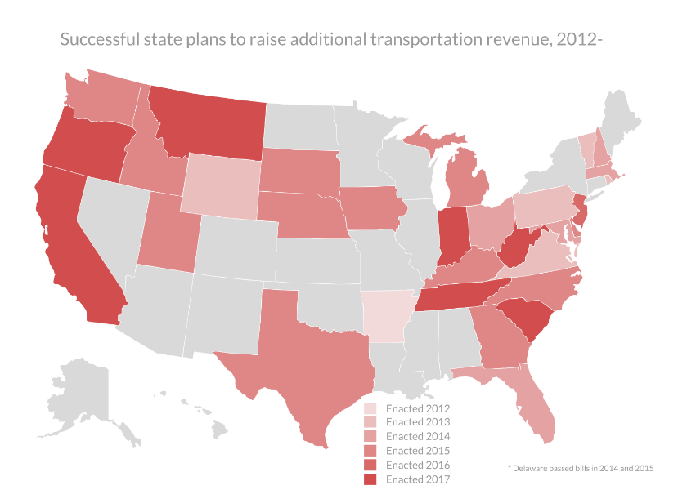
Figure 1. Successful state plans to raise additional transportation revenue, 2012- (Transportation for America, 2017)
So what is ahead for transportation funding and finance? Norboge speculates the following:
- Trump’s infrastructure plan, which will possibly: expand of private credit programs (e.g., TIFIA), incentivize ‘innovative’ approaches to congestion mitigation, ‘liberalize’ tolling policy which opens up the possibility of tolling interstates, fund ports and waterways which will help to alleviate huge project backlogs, and change the environmental review process to allow for more exceptions and potentially less community input [4].
- Autonomous vehicles, which will possibly: change tolling and revenue studies and projections. Do current studies have to change or adapt their assumptions of widespread or low levels of AV adoption? How will investors and issuers of bonds deal with the uncertainty of AVs in their forecasts?
- Electric and fuel-efficient vehicles, which will possibly: cause insurance companies and transportation departments to push for use-based, per-mile VMT tracking and revenue generation. OReGO is an example of this type of program that allows for revenue by mile driven, regardless of the vehicle’s gas consumption [5].
In the near term, the government’s approach to transportation funding may drive cities, regions, and states to capitalize on easy investments and financing—which may mean more road widenings instead of new transit infrastructure or planning for a future with autonomous vehicles. For now, transportation professionals who want to move as many people as possible may instead have to reckon with the reality of needing to, as they say, “follow the money.”

Bibliography
[1] “NCDOT: Finance & Budget,” North Carolina Department of Transportation. [Online]. Available: https://www.ncdot.gov/about/finance/. [Accessed: 06-Feb-2018].
[2] P. M. and S. Box, Airport Cooperative Research Program, Transportation Research Board, and National Academies of Sciences, Engineering, and Medicine, Transportation Network Companies: Challenges and Opportunities for Airport Operators. Washington, D.C.: Transportation Research Board, 2017.
[3] “State Transportation Funding,” Transportation For America, 2017.
[4] “2018 Budget Fact Sheet: Infrastructure Initiative.” White House, Feb-2018.
[5] Oregon Department of Transportation, “Oregon’s Road Usage Charge: The OReGO Program Final Report,” Salem, OR, Apr. 2017.
[6] Nicolas D. Norboge, “Transportation Funding and Finance 101: Why Funding is Policy,” presented at the CSCRS Coffee & Conversation, University of North Carolina at Chapel Hill, 06-Feb-2018.

