# Collaborative Sciences Center for Road Safety

## PROCEEDINGS from “Road Safety – Not a one-way street: Exploring the complexity of pedestrian fatalities”

## Kristen Hassmiller Lich, PhD

## June 5, 2018

Kristen Hassmiller Lich has a background in Public Health and is an Associate Professor of Health Policy and Management at the Gillings School of Global Public Health at the University of North Carolina, Chapel Hill. Her expertise lies in addressing complex health problems with a variety of systems tools, including operations research, systems dynamics, and econometrics. Her research interests include systems science, tobacco policy, and mental health, and she is the recipient of Inaugural Systems Science Scholar award from Academy Health. Hassmiller Lich’s talk for the Collaborative Sciences Center for Road Safety reconvenes the conversation on the applications of systems science to transportation and contextualizes that conversation with examples from an ongoing project investigating the system that contributes to the pedestrian fatality rate in the United States.

Hassmiller Lich begins by introducing attendees to the problem of rising pedestrian fatalities in the United States (Figure 1) and demonstrates that we need a methodology to understand this trend. She then lists multiple hypotheses for the trend – including distraction, speed, and exposure – that were collected during two pedestrian systems mapping workshops. Hassmiller Lich emphasizes the need to test these hypotheses and our own internal reasoning for the trends shown.

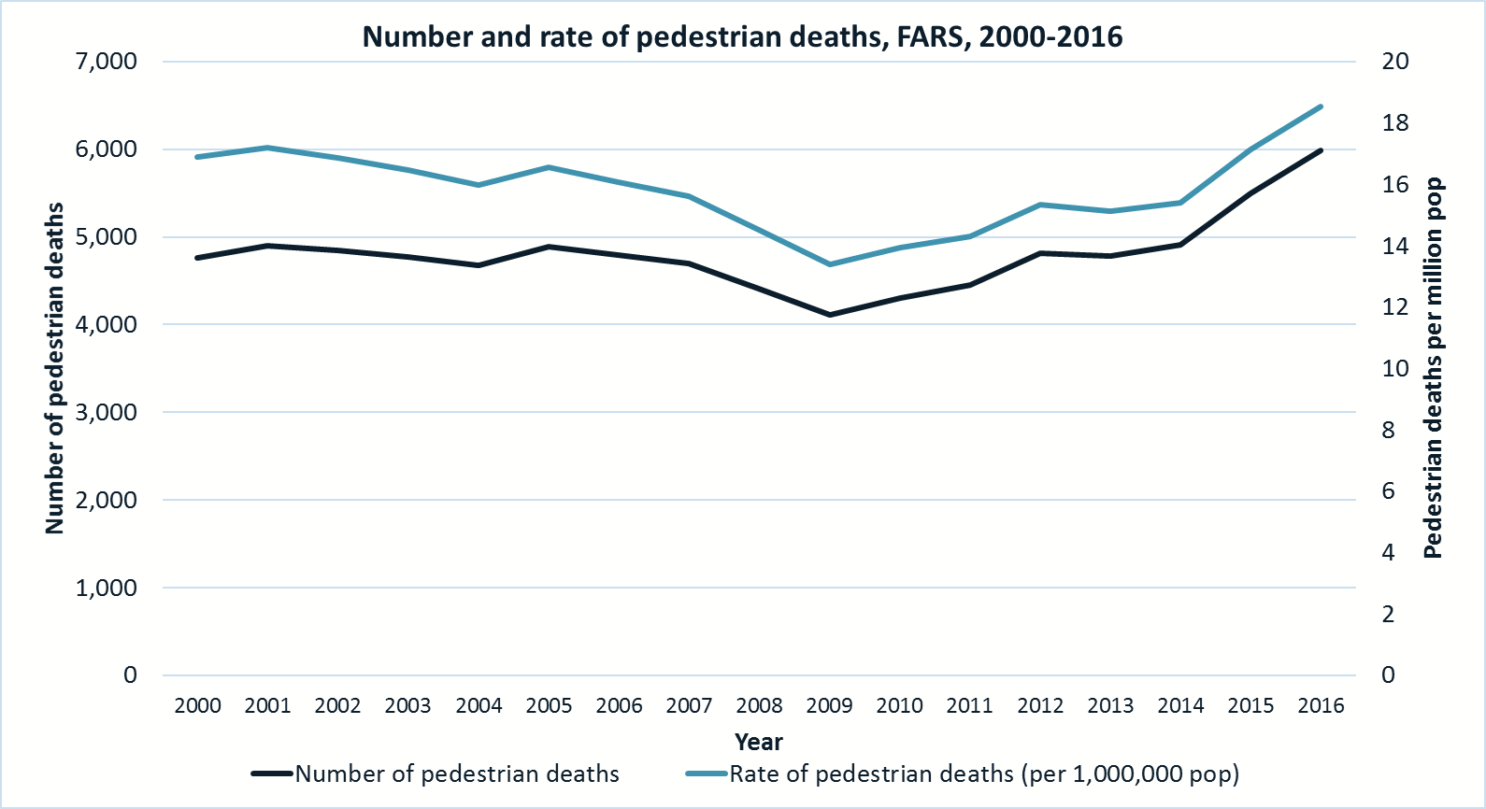

Figure 1: Rising Pedestrian Fatality Trends in the United States

At this point, Hassmiller Lich pivots the conversation to a discussion of systems science and mental models. After asking the crowd what possible explanation they have for the rising pedestrian fatality trend, she shows the first layers of an “iceberg” mental model [1]. The iceberg serves to illustrate different depths of thinking on a specific topic. At the surface level are our reactions to events and our perceptions of trends. However, Hassmiller Lich points out that we need to get under the water to see the deeper levels of thinking of the iceberg. Systems science is a suite of tools that may enable us to do so.

After introducing the iceberg, Hassmiller Lich pauses again to ask the audience what she means by a “system.” As she responds to the audience, she strings multiple answers together to create a clearer picture; systems are integrated, composed of multiple pieces, and nested within a larger environment that may produce complex problems. Although respondents often immediately think of governments or technologies as systems, Hassmiller Lich notes that a system is all of the relevant interconnected elements – forces, laws, and players – that determine an outcome with which we are concerned. This definition echoes that offered by Burgess in the first Coffee and Conversation session:

1. A system is composed of parts that must all be present for the system to carry optimal function.
2. Must be arranged in a specific way for the system to carry out its purpose – in other words, the order counts.
3. Systems have specific purposes within larger systems.
4. Systems maintain their stability through fluctuations and adjustments – in other words, they can maintain harmony through inflows and outflows.
5. Systems have feedback.

Hassmiller Lich returns to the iceberg diagram to illustrate that a bigger picture is needed to avoid putting Band-Aids on major problems. We have to understand the drivers within a system to properly address the problems within a system. However, analyzing and interpreting systems is difficult. Hassmiller Lich offers two explanations for this difficulty:

1. Systems feature detail complexity due to the sheer number of parts and players involved.
2. Systems feature dynamic complexity due to the web of interconnected factors and feedback loops that cause ripple effects throughout a system.

Hassmiller Lich illustrates these feedback loops with a relatively simple causal loop diagram related to the “safety in numbers” phenomenon (Figure 2). Changing one element in the system (e.g. pedestrian exposure) can cause changes throughout the system, for better or worse. Hassmiller Lich then adds a second loop to the first, thereby increasing the complexity of the system. This second loop relates to the increased likelihood of pedestrian fatalities that corresponds to increased exposure. This second loop is a balancing loop that causes the first loop, a reinforcing loop, to trend toward some equilibrium. These two loops demonstrate the dynamic complexity of a system. There may be nonlinear relationships within a system, and changes may occur over long periods of time that differ from the trends in other parts of the system. Due to these complexities, it is easy to miss the true character of a system, particularly if the focus is only on one element in isolation.



Figure 2: Two Loops of the Pedestrian Safety System

Hassmiller Lich uses the complex relationship between the two causal loops to illustrate that many problems within a system can be characterized as wicked problems. There is often disagreement over what a problem specifically is, what the solution is, or if there is even a problem in the first place. In the context of pedestrian safety, the wicked problem of injury reduction may seem to run counter to the goal of promoting active transportation modes.

Fortunately, Hassmiller Lich reminds the audience that systems science can be used to more carefully examine these wicked problems by uncovering the hidden mental models that perpetuate those problems. She unveils the full iceberg (Figure 3) and notes that by uncovering mental models, we can find holes in the system.

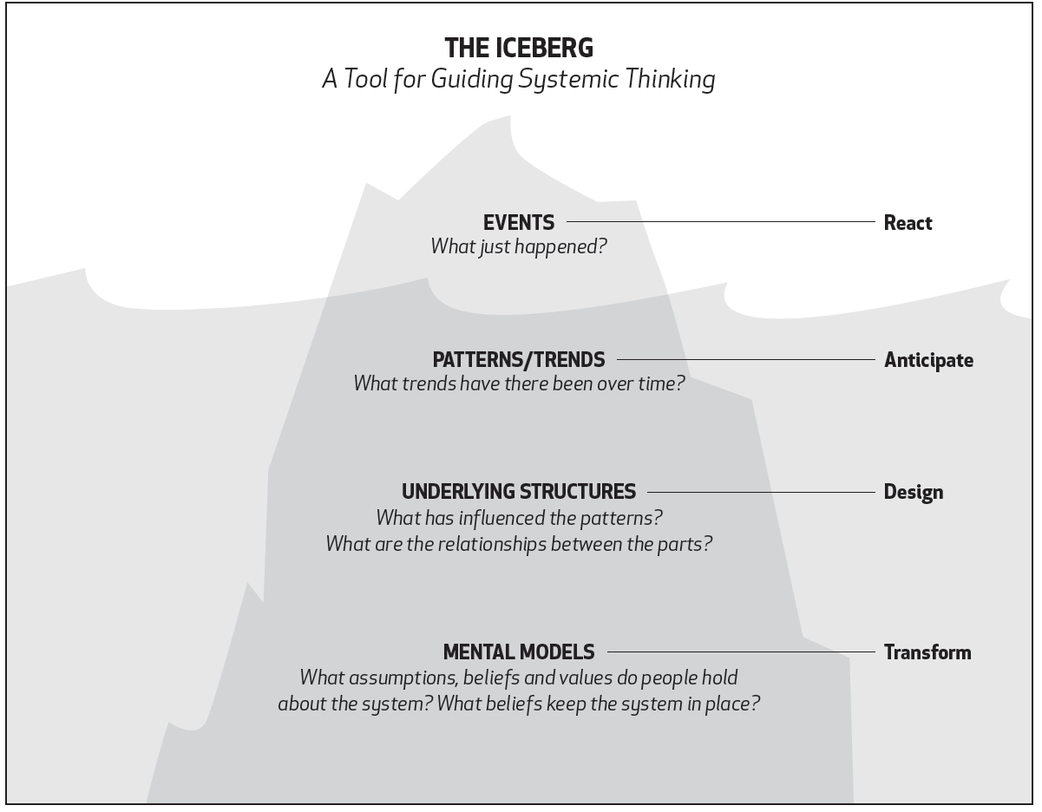

Figure 3: The Full Iceberg of the System [1]

Hassmiller Lich re-introduces systems science as a suite of tools to uncover those hidden mental models and describes systems analysis as a continual process of zooming in, zooming out, zooming in, and zooming out to test our hypotheses regarding specific problems. Often, our intuitions on topics are flawed, so we must use this iterative process to assess our own mental models and bridge the gap between our thoughts and those of other stakeholders. Hassmiller Lich encourages the audience to think about problems within a system through a double-loop learning framework (Figure 4). Traditionally, we conduct projects by starting with some hypothesis based on our own intuition. We then gather data relevant to that specific hypothesis and then recommend solutions based on the data we’ve gathered. However, Hassmiller Lich notes that because systems are dynamic, our hypotheses should be alive and constantly tested. This will allow us to gather better data and refine our mental models. Ultimately, the solutions we find may be very different from the conclusions we initially believed. Hassmiller Lich quotes Pete Senge’s work in *The Fifth Discipline* to illustrate this point. “Systems thinking is a discipline for seeing wholes. It is a framework for seeing interrelationships rather than things, for seeing patterns of change rather than static ‘snapshots’… Today systems thinking is needed more than ever because we are becoming overwhelmed by complexity. Perhaps for the first time in history, humankind has the capacity to create far more information than anyone can absorb, to foster far greater interdependency than anyone can manage, and to accelerate change far faster than anyone’s ability to keep pace.” [2]

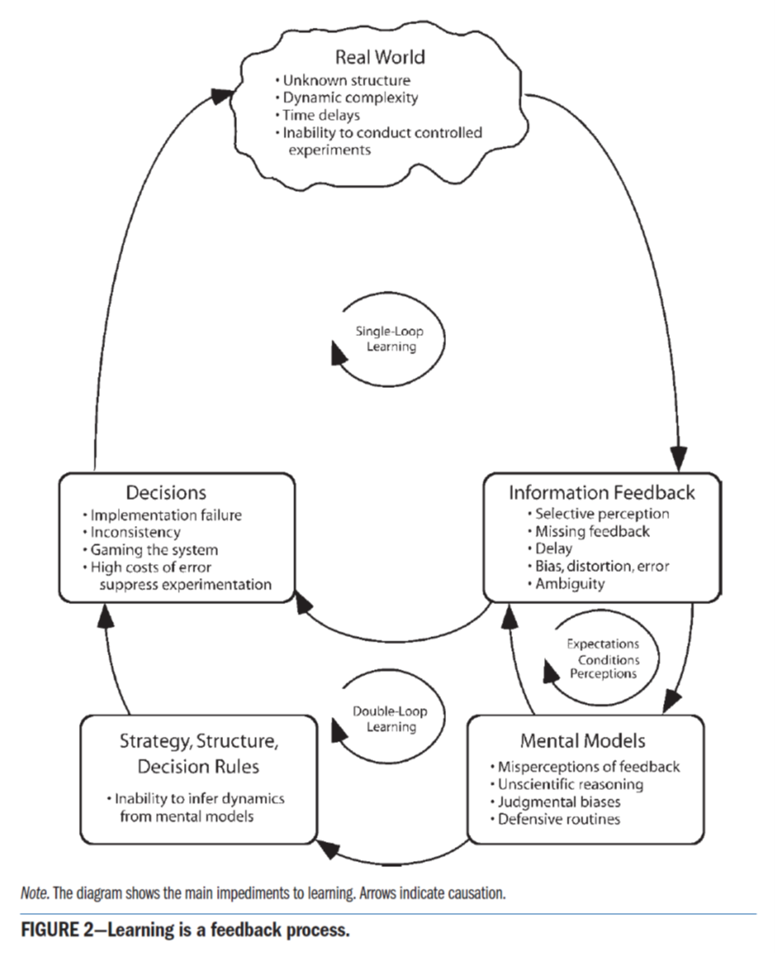

Figure 4: The Double Loop Learning Process [3]

Hassmiller Lich concludes the discussion by first showing a series of causal loop diagrams developed through an ongoing CSCRS project and then discussing the relevance of this type of analysis for solving systems problems. The diagrams were developed through mapping exercises at two expert workshops. Hassmiller Lich notes that the potential explanations for the trends in pedestrian fatalities were uncovered through these mapping exercises, and now those hypotheses (and their underlying mental models) can be tested through both careful inspection of data and systems simulation. Hassmiller Lich cites the Polio Zero initiative as an example that may be comparable to Vision Zero for testing hypothesis to ultimately arrive at a cost-effective solution that includes stakeholders from across the discipline (see [4, 5]). Hassmiller Lich leaves the audience with a charge to invest in systems science because it builds a foundation for better, smarter problem-solving.

**Discussion**

There was no formal discussion held during this proceedings due to two factors: 1. The length of the presentation itself; 2. The fact that Hassmiller Lich took and answered questions, as discussed in the proceedings, during the presentation itself. However, several attendees did approach Hassmiller Lich afterward for more direct questioning and to thank her for the presentation.

# **References**

|  |  |
| --- | --- |
| [1] | Northwest Earth Institute, "A Systems Thinking Model: The Iceberg," Northwest Earth Institute, 2018. [Online]. Available: https://www.nwei.org/iceberg/. [Accessed 4 June 2018]. |
| [2] | P. Senge, The Fifth Discipline, Currency, 1990. |
| [3] | J. D. Sterman, "Learning from Evidence in a Complex World," American Journal of Public Health, vol. 96, no. 3, pp. 505-514, 2006. |
| [4] | K. M. Thompson and R. J. Duintjer Tebbens, "National choices related to inactivated poliovirus vaccine, innovation and the endgame of global polio eradication," Expert Review of Vaccines, vol. 13, no. 2, pp. 221-234, 2014. |
| [5] | K. M. Thompson, R. J. Duintjer Tebbens, O. M. Kew, R. W. Sutter, R. B. Aylward, M. Watkins, H. Gary, J. P. Alexander, L. Venczel, D. Johnson, V. M. Caceres, N. Sangrujee, H. Jafari and S. L. Cochi, "Development and Consideration of Global Policies for Managing the Future Risks of Poliovirus Outbreaks: Insights and Lessons Learned Through Modeling," Risk Analysis, vol. 26, no. 6, pp. 1571-1580, 2006. |