CSCRS

Technology Transfer Plan

December 20, 2018

Contents

Introduction 1
Identifying and Involving Stakeholders in the CSCRS Research Program ........................................................... 2
Assisting Stakeholders in Implementing and Deploying Research Outputs 3
Adoption-ready T2 projects 4
Professional development and education 6
Commercialization Process of Research Outputs 6
Collection and Use of Licensing Revenues to Provide Further Support for Research and Technology Transfer 6
Dissemination of Research Results 6
Common dissemination tactics for all projects 7
For projects selected for focused T2 activities/resources .8
How Research Outputs, Outcomes and Impacts Will Be Tracked and Reported 8
How Corporate Research Support Will Be Increased .8
Technology Transfer Goals and Performance Measures 9
Center Commitment to Technology Transfer 9

Introduction
The mission of the Collaborative Sciences Center for Road Safety (CSCRS) is to create and exchange knowledge to advance transportation safety through a multidisciplinary, systems-oriented approach. By engaging perspectives from behavioral, engineering, epidemiological, planning, and other disciplines, CSCRS is implementing innovative, transdisciplinary research, education and professional development activities designed to improve safety on U.S. roadways.
This Technology Transfer (T2) Plan outlines how CSCRS will facilitate the adoption and integration of its research into practice – a tenet at the core of its mission and strategic goals.
Generally, three important questions drive all T2 activities at CSCRS:
- Who is waiting for this research?
- Why do they need it?
- How will/can they use it to help them improve safety on our roadways?
Specifically, this plan describes what activities will be conducted to meet the T2 objectives, and what protocols will be followed for research projects. Adhering to the U.S. Department of Transportation’s (USDOT) guidance for the T2 Plan, this plan does not describe CSCRS professional development and education activities in detail. However, these activities also are critical to the broader consideration of technology transfer to reach practitioners, students and professionals across all of CSCRS’s target audiences.
According to a National Cooperative Highway Research Program (NCHRP) report on the topic, T2 is defined as activities “leading to the adoption of a new-to-the-user product or procedure” and/or implementation of new and/or updated research results by any user or group of users. Activities leading to the adoption of innovations could include “knowledge transfer, training and education, demonstrations and showcases, communications and marketing efforts, and technical assistance.” The report points out that the process of change for the transportation research world is complex as there are cultural and technical issues to address as well. The complexity of change, and opportunities for impact, are amplified as CSCRS is a National University Transportation Center (UTC) focused on extending reach and research beyond transportation to public health, planning and several related disciplines.
This is a living document and may be adjusted and improved throughout the life of the grant, but T2 has been and will remain an important focus of the entire CSCRS team and all activities.

Identifying and Involving Stakeholders in the CSCRS Research Program
Stakeholders involved in CSCRS research are numerous, varied, and evolving every day as research progresses and informs the T2 process. For example, the goal of a year one CSCRS research project was to identify key opinion leaders in cities and organizations across the country; another involved surveying key stakeholders to identify critical safety research needs. Stakeholder groups are important as direct audiences for CSCRS as well as for their connections to indirect audiences that may benefit from CSCRS-produced research.
Core CSCRS stakeholders include:
- Advisory Board members represent the following organizations (additional information available on CSCRS website):
  - AAA Foundation for Traffic Safety
  - Advocates for Highway and Auto Safety
  - American Association of State Highway and Transportation Officials (AASHTO)
  - U.S. Centers for Disease Control and Prevention’s (CDC) National Center for Injury Prevention and Control
  - Institute of Transportation Engineers (ITE)
  - National Association of City Transportation Officials (NACTO)
  - National Association of State EMS Officials
  - National Safety Council
  - University of South Carolina, School of Law
  - Toyota’s Collaborative Safety Research Center
  - Uber
  - Vision Zero Network
  - Volkswagen Group of America, Inc.
- Collaborators of research, education and professional development activities (including co-funders for cost-match projects), including:
  - City, state and regional departments of health, planning, public works and other public agencies (such as Durham MPO and city of Durham)
  - Federal agencies (such as CDC, Department of Energy and National Science Foundation)
  - Non-profits (such as National Association of City Transportation Officials)
  - Private foundations (including MacArthur Foundation Endowment and others)
  - Safety and defense departments (including Tennessee Department of Safety & Homeland Security)
  - School districts (such as Knox County Schools and Chapel Hill-Carrboro City Schools)
  - State Departments of Transportation (including Caltrans, NCDOT, TDOT and others)
  - State Highway Safety Program Offices (such as the North Carolina Governor’s Highway Safety Program)
  - USDOT (including OST, NHTSA, FHWA, FMTSA, FTA or others)
  - Universities in the United States and internationally (including Jiaotong Universities in China)

- Industry or member organizations that influence target audiences and professions, including:
  - AARP
  - Alliance of Automobile Manufacturers
  - American Planning Association (APA)
  - Association of Pedestrian and Bicycle Professionals (APBP)
  - American Public Health Association (APHA)
  - Council of University of Transportation Centers (CUTC) and member UTCs
  - Governors Highway Safety Association (GHSA)
  - Institute of Transportation Engineers (ITE)
  - Safe States Alliance
  - Society of Automotive Engineers, International (SAE)
  - Society for Advancement of Violence and Injury Researchers (SAVIR)
  - Transportation Research Board (TRB) committees and executive level leadership
  - TRB National Cooperative Highway Research Program
  - Women’s Transportation Seminar (WTS)
- Researchers, staff and students at CSCRS Consortium member campuses
- Students and teachers (at community colleges, high schools and elementary schools)

Assisting Stakeholders in Implementing and Deploying Research Outputs
The need to identify and engage end-user champions and to provide demonstrations of implementation are very important to make T2 a success. 1 In addition to the processes described here for research outputs, professional development activities comprise a considerable proportion of CSCRS work. For research projects, each must be carefully assessed and matched with appropriate T2 activities. CSCRS research ranges from foundation to applied, meaning some are more “adoption ready” than others so different activities will apply depending on the project. All research project results will be disseminated and/or put into practice using a combination of communication and funding activities (see workflow illustration on p. 4).

The following schematic illustrates the basic workflow and points in the research development process where T2 opportunities are considered.
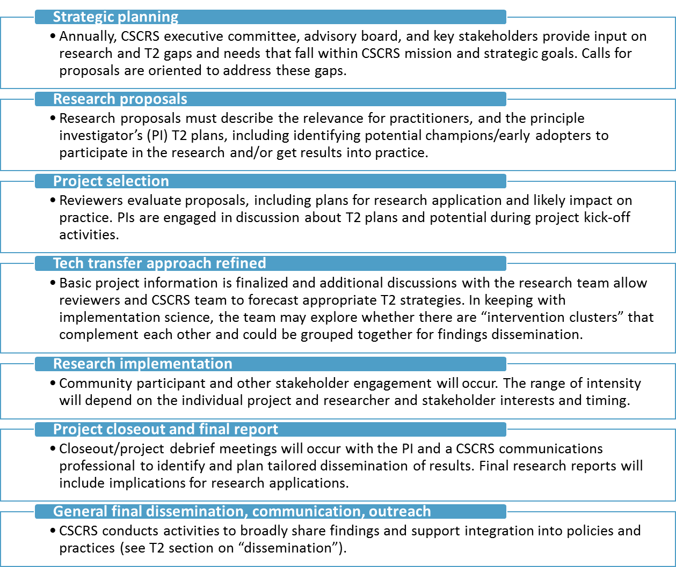

While informed by lessons learned from relevant work on similar projects, the CSCRS T2 workflow and process is flexible and will be adjusted throughout the life of the grant to account for what is and is not working, based on goals and metrics discussed later in this plan.

Professional development and education
Per USDOT’s guidance for the T2 Plan, this plan focuses on transfer of research findings. However, CSCRS also invests heavily in professional development and education, with two of its three main goals being centrally focused upon them. Professional development activities are critical to the integration of new research into existing practice and collegiate level professional preparation. Education activities foster an understanding of roadway safety principles and inspire interest in related careers for K-12 students. The CSCRS website describes professional development and education objectives and activities.

Commercialization Process of Research Outputs
Our research results in outputs such as data sources, reports, and training materials aimed at improving the decision-making and capacity of safety professionals from a variety of fields. It is possible that CSCRS research would also generate technologies such as phone applications (apps), innovations related to dedicated short-range communications (DSRC) that make phone-to-vehicle and vehicle-to-infrastructure or people (V2I and V2X) communications possible and/or algorithms for big data management for the purposes of research, safety, and simulation. Per its proposal to USDOT, CSCRS stands by its commitment to equity and open access to its findings and data that may support a broader realization of the safety benefits of transportation improvements. All commercialization decisions would be made through the lens of staying consistent with CSCRS goals and mission. UNC and other consortium member universities have experience assessing whether commercialization of research is worthwhile and appropriate and the process for doing so. CSCRS intends to take advantage of these resources as appropriate to evaluate commercialization opportunities. For example, UTK has access to TennSMART (tennsmart.org) members, a consortium of public agencies and private companies focused on advancing intelligent mobility in Tennessee and whose interests could align with commercialization of some types of CSCRS research.
At UNC, the Office of Technology Commercialization (OTC) in the Office of the Vice Chancellor for Innovation Entrepreneurship and Economic Development provides guidance, grants, and resources to faculty, staff, and students interested in translating research into marketable products. They regularly handle federally funded research findings and have a commitment to supporting technology transfer, bringing to bear their staff devoted to commercialization, market research, and strategic partnerships. Related to commercialization, OTC’s work proceeds through five main steps:
- Evaluation: OTC first assists in the evaluation of commercialization potential of a research result or technology and whether a patent is appropriate. Information gathered during this assessment phase will guide whether to license the invention to an existing company or form a startup company.
- Protection: Determination is made as to whether a patent, copyright, trademark, or none is appropriate.
- Marketing: OTC facilitates garnering initial assessment for interest and feedback from others in the same industry to refine the business strategy. Legal agreements are used to protect sharing of confidential information.
- Choosing a partner: The licensee will be selected using a variety of criteria including experience in the field, past success, and sufficient resources. The other option is formation of a startup company.
- Commercialization: Regardless of whether an existing company or startup, now the process begins to work towards getting the innovation out to the world.

CSCRS will utilize these processes and resources as we encourage staff and student entrepreneurship and innovation in both private and public sectors.

Collection and Use of Licensing Revenues to Provide Further Support for Research and Technology Transfer
UNC’s patent and invention policy and copyright policy guide licensing and commercialization. Per the policy, when the University generates licensing revenue through commercialization of its patents and copyrights, 40 percent of that revenue is distributed to the department of the relevant inventors and authors (in this instance, UNC Highway Safety Research Center). HSRC has the ability to reinvest all royalties into further CSCRS research. UNC also uses a separate percentage of licensing revenue to fund its patent budget in support of university units, including HSRC and the UNC-based CSCRS partners. As revenue-generating opportunities are realized, CSCRS will reinvest any available funds to support further safety research, professional development, and student education initiatives.

Dissemination of Research Results
While opportunities to disseminate CSCRS research results may occur at any point, the time of project proposal initiation and closeout are important opportunities for CSCRS researchers to routinely consider and prioritize T2 in their work. Specifically, project PIs and teams are required to identify key stakeholders (many described previously in the “stakeholders” section), product outputs (guides, reports, trainings, presentations, etc.) and implications for practice of their proposed and/or completed project. This information is then used to help customize research dissemination plans and to help identify projects for focused T2 efforts. Generally, key stakeholders and potential users of CSCRS research will receive results in a variety of ways.
CSCRS communications staff will leverage communication channels of its consortium members, advisory board members, stakeholders and other identified potential end users so the information meets potential users and decision-makers “where they are.” For example, CSCRS leadership will participate in regularly scheduled meetings, webinars and conferences where key stakeholders meet. This is a particularly important component of the CSCRS T2 Plan with regard to expanding to new and non-traditional safety audiences, as many of the potential end users of CSCRS research are not familiar with CSCRS or even the idea of what a USDOT UTC is, and they cannot be expected to seek out information via the CSCRS website or newsletter without an initial contact or invitation.
The following figure further articulates the range of potential outlets and tactics that CSCRS will use to disseminate information to target audiences and end users, depending on the nature of the research and opportunities available:

Dissemination and practice integration tactics

Setting or Tactic | Potential activities | How CSCRS integrates support for these activities into project lifecycle
Conferences and meetings | - Membership and participation in professional committees  - Organizing, hosting a conference/meeting  - Presentations at conferences/meetings | Slides are a required deliverable for all research projects in order to expedite presenting research.
Instructional activities | - Courses  - Interactive workshops and training  - Lectures  - Webinars | The project proposal and closeout processes capture opportunities to integrate findings into courses, workshops and webinars.  In addition, CSCRS has separate projects entirely devoted to professional development and education.
Print and web-based publications and materials | - Best practice manuals/guides/fact sheets  - Guidelines  - Job aids (flow charts, checklists)  - Journal articles and position papers  - Newsletters/articles (including newsletters authored by CSCRS and our partners and stakeholders)  - Press release/media kits  - Reports/papers/research syntheses  - Tech briefs  - Social media  - Website content | Final report template includes an executive summary and abstract requirement to expedite succinct delivery of key lessons.
Capacity building | - Demonstration grants for end users and researchers to integrate research findings into agency practices.  - Implementation case studies using participatory research designs.  - Embedded personnel who temporarily work in an agency with the explicit goal to assist in the onboarding of new processes or practices informed by research results. | Post-project
Targeted technical assistance | - Site visits or remote meetings  - Peer-to-peer learning and support  - Data system development and sharing  - Cooperative twinning partnerships | Post-project

How Research Outputs, Outcomes and Impacts Will Be Tracked and Reported
Research outputs, outcomes, and impacts will be tracked and reported through existing CSCRS reporting and communications channels. In its first year of existence, CSCRS established a number of mechanisms to support rigorous tracking and reporting of both short and long-term outcomes and impacts. Plans are also underway to develop a formal project management system, building from lessons and models used by longer-running UTCs.
Tracking mechanisms, which can be used from project initiation to closure and beyond to highlight longer-term impacts, include:
- Regular bi-monthly team and researcher business and update calls, in which we seek qualitative info on project status, outputs, outcomes, and impacts
- Ongoing comprehensive digital tracking of CSCRS activities and accomplishments to enable timely reporting in the official PPPR format, responses to ad-hoc requests, and other reporting processes and documentation to USDOT (e.g., TRB Research in Progress and TRID databases)
- The CSCRS website, which includes a comprehensive catalog of research funded, as well as professional development and educational activities and events. The website archives all products produced (outputs), including presentations and slides that can be used in a variety of outlets to support T2. Google Analytics is embedded in all pages and can be used to monitor visit, general use, etc. This web tracking tool can also be used to inform and adjust web content accordingly to use.
- Traditional (i.e., newsletter) and social media are used to promote CSCRS efforts and can also support tracking efforts. The website, newsletter, and social media feature the accomplishments and impacts of CSCRS projects, staff, and students. CSCRS will track growth in the newsletter and social media following, as well as use indicators that show reach and distribution of resources shared with other audiences.
Just as T2 is integral to the general operations of CSCRS, so too is it integral - and very much a part of - the existing CSCRS reporting processes.

How Corporate Research Support Will Be Increased
Corporate research support is currently sought by CSCRS for funding purposes (e.g. cost-match projects), for research dissemination assistance (e.g. to communicate with existing distribution lists and audiences) and for strategic guidance and support (e.g. as Advisory Board members including Volkswagen, Uber, Toyota and others). As relationships continue to be built upon through the life of this UTC grant, additional opportunities for support and collaboration will develop. Examples of corporate research support being actively pursued now include UNC researchers who have been in communication with firms such as design.ai to develop vehicle to pedestrian communications and incorporate findings from ongoing CSCRS research. Another UNC researcher has been in communication with Google about ways to use and expand its open source platform. CSCRS seeks sponsorship for special events as appropriate, and has been successful in securing this type of corporate support and financial relationship from various entities for several events already (e.g. Safe Systems Summit and Safety Sunday @ TRB). CSCRS plans to leverage these relationships towards further corporate support in the future. CSCRS recognizes the need to nurture and grow corporate relationships not only as an important part of meeting funding match requirements but also to increase corporate support financial support of the ultimate goal: to transform the practices of organizations that impact safety.

Technology Transfer Goals and Performance Measures
We are committed to the measurement, monitoring and improvement process to ensure we are meeting our mission. The CSCRS performance plan captures a wide range of metrics. Developed based on the main goals of the CSCRS as outlined in its Strategic Roadmap, the following table specifies the T2-specific measures and targets:
 | Research Performance Measure | Target
Output #1 | Organize and hold conferences through 2021. | 3
Output #2 | Annual journal manuscripts, publications, articles, posts, media stories, etc. | 30
Outcome #1 | Average annual number of opportunities/instances to share transportation safety expertise at conferences, professional meetings and through media. | 20
Outcome #2 | Annual number of adoption, use or reference to CSCRS products, or influence on national or state research agendas. | 5
Impact #1 | Annual instances integrating CSCRS research results into agency or stakeholder practices that demonstrate use of research results in practice. | 3
Impact #2 | Annual instances integrating CSCRS research results into organizational/workforce capacity building that demonstrate use of research results in capacity building  activities conducted by local, regional, state or national level agencies. | 3

Center Commitment to Technology Transfer
As discussed throughout this plan, CSCRS and each of its consortium member universities are fully committed to T2. CSCRS has several dedicated communications professionals on the team – both at the lead University of North Carolina Chapel Hill (UNC-CH) campus and at each individual consortium member campus – to conceptualize, coordinate, facilitate, communicate and track all T2 activities. This commitment of resources will continue throughout the life of the project, and – if needed – can be increased to meet the stated goals in this plan.
In addition, the existing CSCRS T2-related processes – as laid out in this plan – will be evaluated throughout the life of the grant, and updated and improved upon to increase success of all T2 activities across the Center.
###

National Cooperative Highway Research Program (2005). Transportation Technology Transfer: Successes, Challenges, and Needs, Synthesis 355. Retrieved from http://onlinepubs.trb.org/onlinepubs/nchrp/nchrp_syn_355.pdf
National Cooperative Highway Research Program (2014). Guide to Accelerating New Technology Adoption through Directed Technology Transfer, Report 768. Retrieved from http://nap.edu/22342.

